Creating the product details page. Using the grid layout

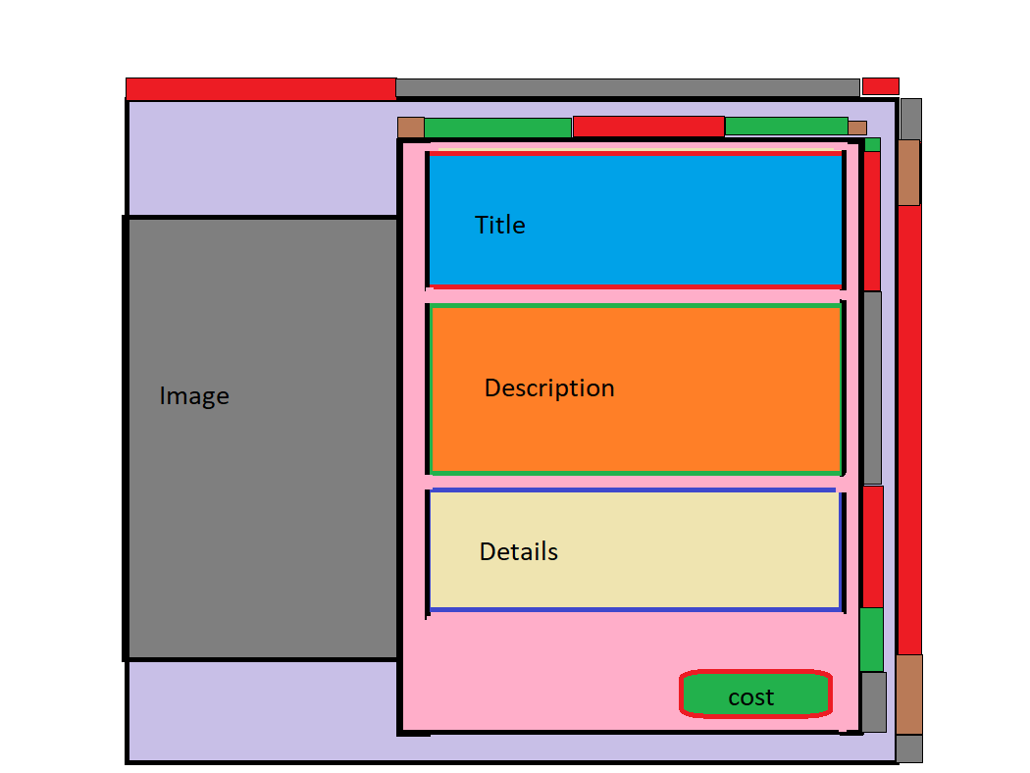

The outer grid has 5 rows and 3 columns, column 1 houses the image, column 2 houses the product detail body. And column 3 is just acting as our margin.

The product detail body is also a grid of 6 rows and 5 columns. row 1 and col 1 are margins. Row 2 would be our title, row 3 would be our description, row 4 – details row 5 a little space before row 6 – to house the cost/buy button